GRC101 Laboratory Report

Course Code: GRC101
Course Title: Introduction to GRC Engineering
Student Name: Imelda Sanya
Registration Number: C11/26/CGRCE/17576
Email: sanyanabs16@gmail.com
Cohort/Batch: 11
Linux Distribution Used: GitHub Codespaces (Linux)
Date Submitted: 17/07/2026

1. Introduction
This laboratory was focused on learning basic Linux command-line skills and understanding how they can support Governance, Risk, and Compliance (GRC) activities.
As a GRC engineering trainee, it is important to understand how organisations manage policies, risk records, compliance documents, and audit evidence. These records need to be organised properly, protected with the right permissions, and easy to retrieve during audits.
During this practical, I used a Linux environment through GitHub Codespaces to perform tasks involving directory creation, file management, searching, permissions, metadata checking, and creating a compressed archive. The activities helped me understand how Linux commands can be applied in real GRC scenarios.

2. Task Evidence

Task 1 – Open the Shell and Identify the Environment

Objective
The purpose of this task was to identify the Linux environment I was working on by checking my username, hostname, date, operating system information, and shell.
Commands Used
whoami
hostname
date
uname -a
echo $SHELL

Result

I used these commands to understand the Linux environment provided by GitHub Codespaces. The commands displayed my username, system information, and the shell available.
GRC Connection
Before performing administrative or audit-related activities, it is important to confirm the environment being accessed. This helps ensure evidence is collected from the correct system.
Screenshot
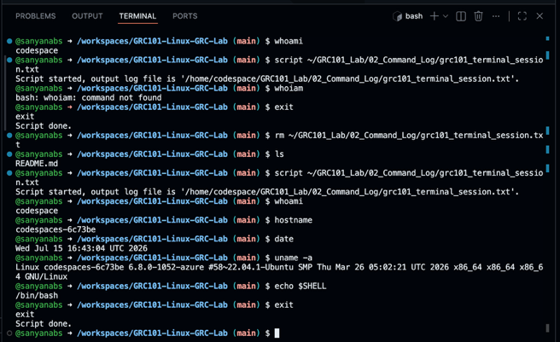

Task 2: Create the Main GRC101 Laboratory Workspace

Objective

The purpose of this task was to create an organised folder structure for storing GRC-related records and evidence.

Commands Used
cd ~

mkdir -p GRC101_Lab/{01_Screenshots,02_Command_Log,03_GRC_Evidence_Folder}

ls -l GRC101_Lab
GRC evidence folders created:
mkdir -p Governance Risk Compliance Audit_Evidence Meeting_Records Archive

Result
The required GRC folder structure was successfully created.
Created folders:
- Governance
- Risk
- Compliance
- Audit_Evidence
- Meeting_Records
- Archive
GRC Relevance

During audits, evidence needs to be organised clearly so that auditors can easily locate required documents.

Screenshot

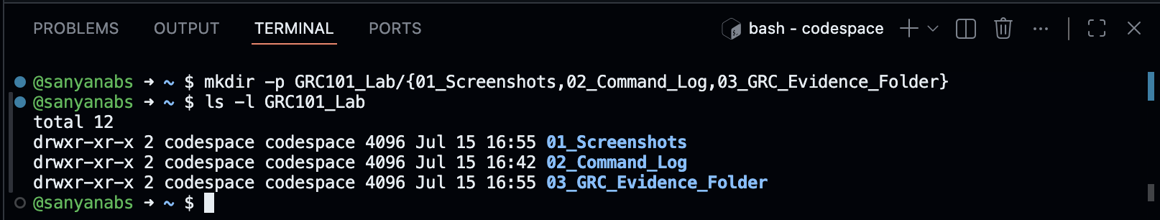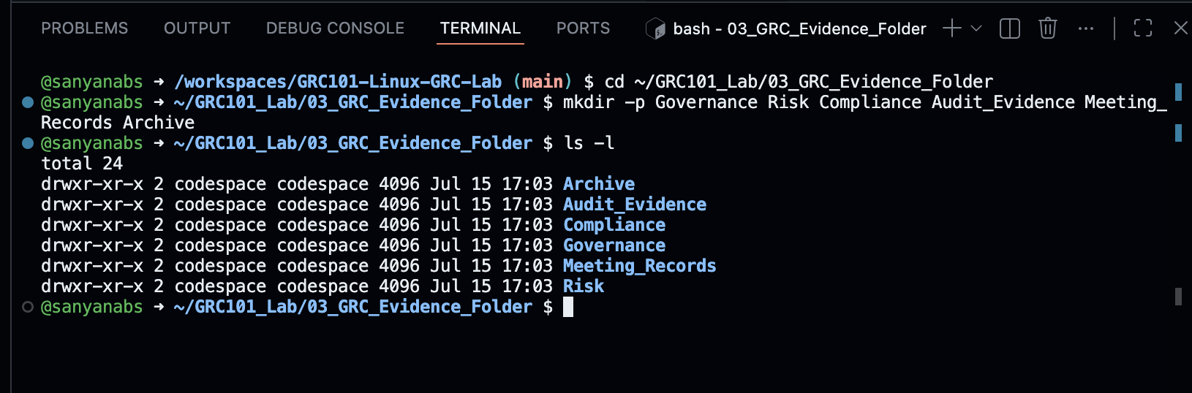

Task 3: Navigate the Linux File System

Objective

The objective was to practice moving between directories using Linux navigation commands.

Commands Used
pwd

cd ~/GRC101_Lab

cd 03_GRC_Evidence_Folder/Governance

cd ..

cd ./Risk

cd ../Compliance

cd ~

Result
Successfully navigated through different folders using Linux navigation commands.

Explanation
pwd displays the current working directory.
cd .. moves to the parent directory.
cd ~ returns to the user's home directory.
. represents the current directory.
.. represents the parent directory.
An absolute path provides the complete location from the root directory, while a relative path starts from the current location.
GRC Relevance

Correct navigation reduces the risk of modifying or storing evidence in the wrong location.

Screenshot

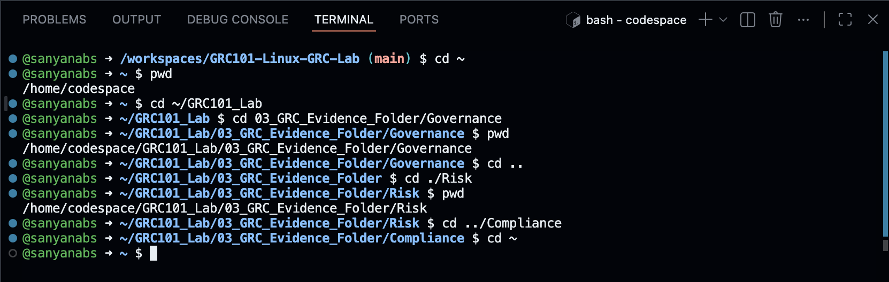

Task 4: List and Inspect Files and Directories

Objective

The purpose was to understand how Linux displays files and how hidden files are managed.

Commands Used
ls

ls -l

ls -la

ls -lh

echo "Internal GRC workspace" > .workspace_note

ls -la

Result
Different directory listing formats were reviewed, and a hidden file was successfully created and displayed.

Explanation
- ls displays files and directories.
- ls -l provides detailed information.
- ls -la displays hidden files.
- ls -lh displays file sizes in a readable format.
GRC Relevance

Hidden configuration files can contain important system information. Understanding file visibility helps with evidence management.

Screenshot

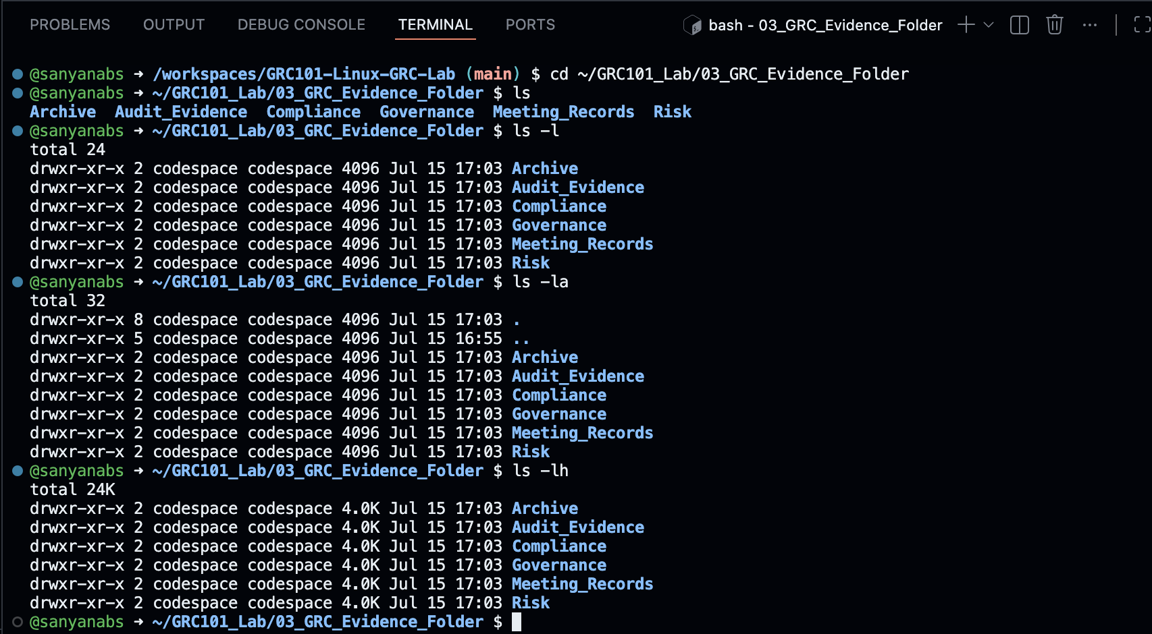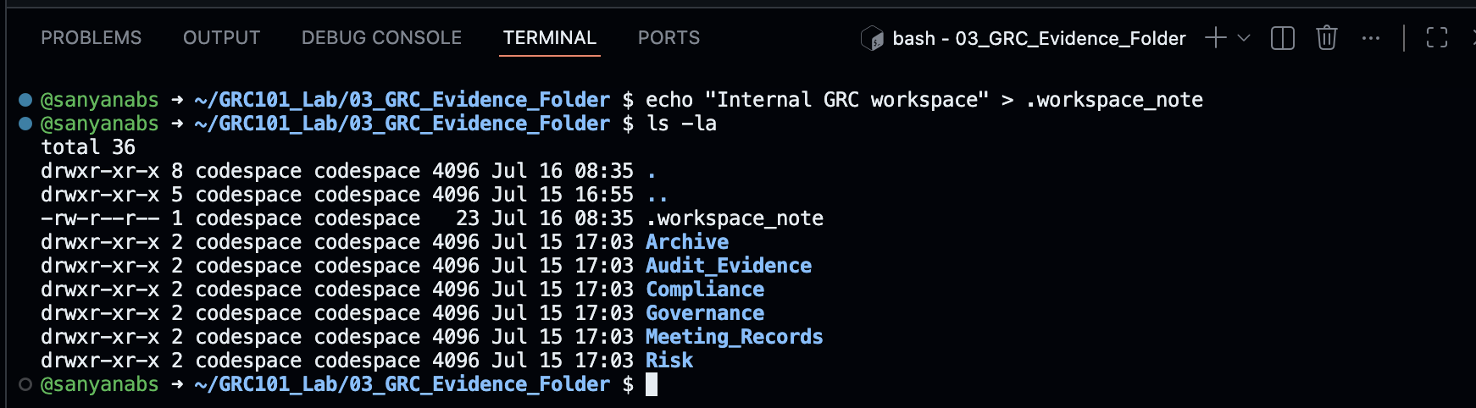

Task 5: Create and View GRC Files

Objective

The purpose of this task was to create sample GRC documents.

Commands Used
Created:
touch Governance/information_security_policy.txt

touch Risk/risk_register.txt

touch Compliance/compliance_checklist.txt
Added information using:
echo
cat
head

Result
The following GRC records were created:
- Information Security Policy
- Risk Register
- Compliance Checklist
GRC Relevance

Policies, risk registers, and compliance checklists are common documents maintained by GRC teams.

Screenshot

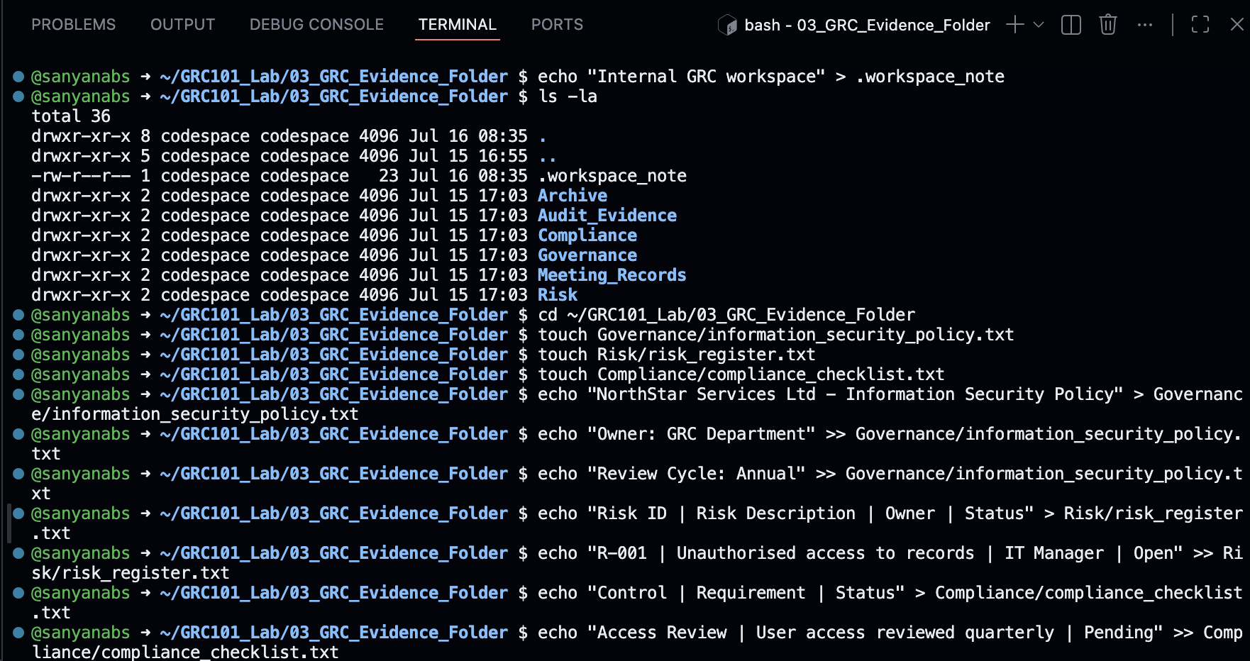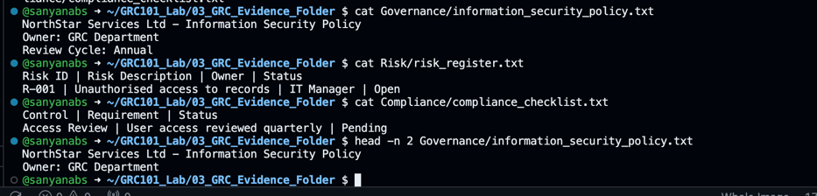

Task 6: Copy, Move and Rename GRC Records

Objective

The objective was to manage evidence files by copying, moving, and renaming them.

Commands Used
cp Governance/information_security_policy.txt Audit_Evidence/

cp Risk/risk_register.txt Archive/risk_register_backup.txt

mv Compliance/compliance_checklist.txt Compliance/grc_compliance_checklist.txt

mv Meeting_Records Archive/Old_Meeting_Records

Result
Files were copied, renamed, and moved successfully.

Explanation
cp creates a duplicate while keeping the original.
mv moves or renames files.

GRC Relevance

Keeping copies of evidence is useful when providing documents for audit review.

Screenshot

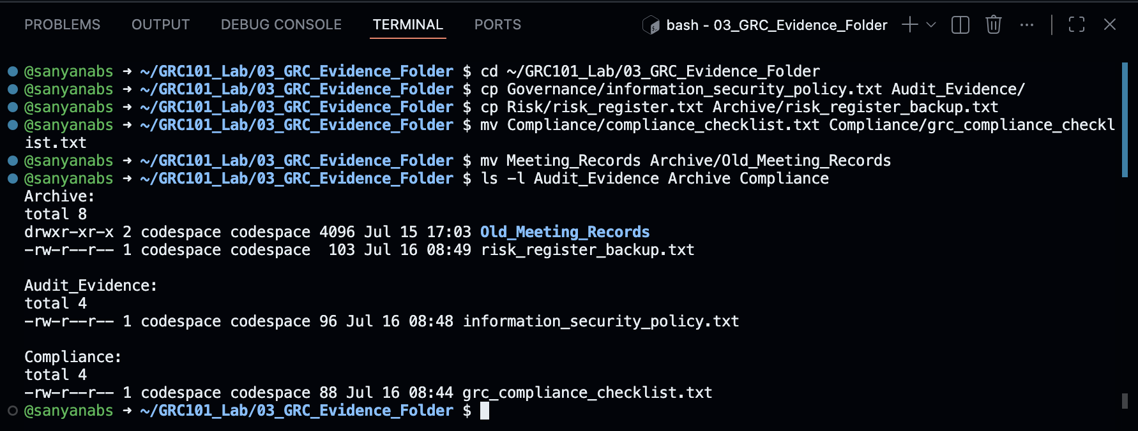

Task 7: Search for Files and Information

Objective

The purpose was to learn how to locate files and search inside documents.

Commands Used
find . -type f

find . -type f -name "*.txt"

find . -type f -iname "*policy*"

grep -R "Owner" .

grep -Rni "access" .

Result
Files and text information were successfully located.

Explanation
find searches for files.
grep searches inside files for specific text.

GRC Relevance
During audits, teams need to quickly locate evidence and specific information within documents.

Screenshot
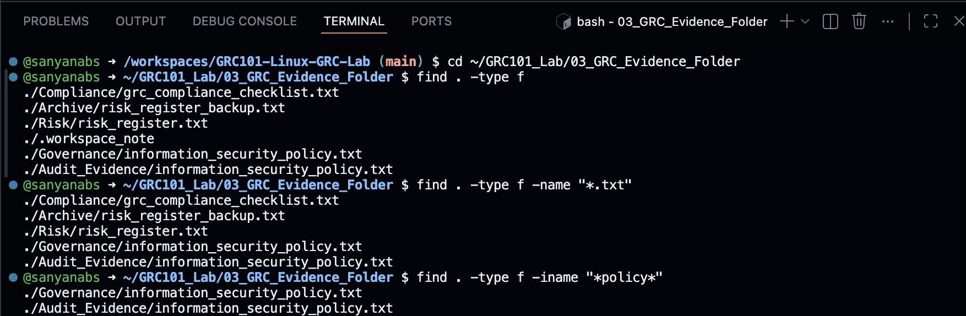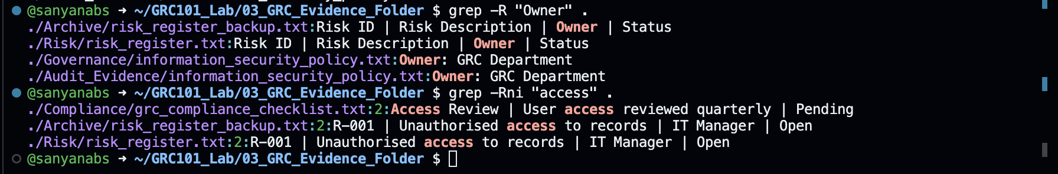

Task 8: View File Metadata and Inode Numbers

Objective

To inspect file details and metadata.

Commands Used
ls -li Governance/information_security_policy.txt

stat Governance/information_security_policy.txt

df -h

df -i

Result
File ownership, permissions, timestamps, inode information, and storage usage were displayed.

GRC Relevance

Metadata supports evidence integrity because it shows important information about a file's history and ownership.

Screenshot
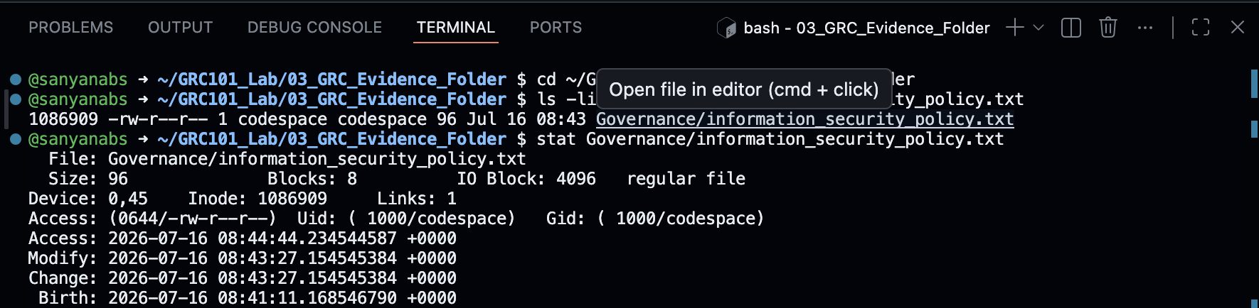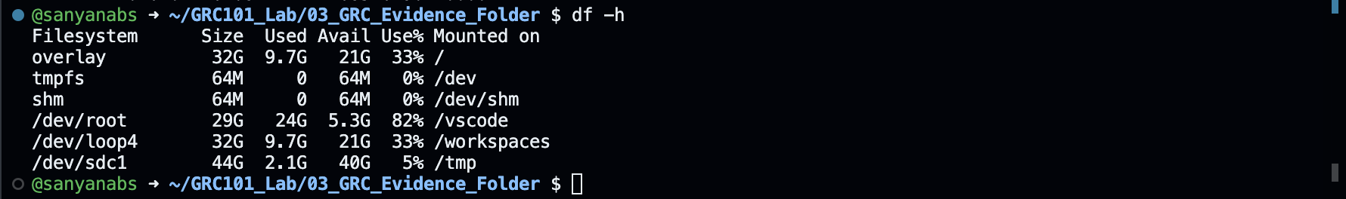

Task 9: Basic Permissions and Responsible Use of sudo

Objective

To understand Linux access permissions.

Commands Used
ls -l Governance/information_security_policy.txt

chmod 640 Governance/information_security_policy.txt

ls -l Governance/information_security_policy.txt

sudo -l

Result
The file permissions were changed successfully.
Permission meaning:
- Owner: Read and write
- Group: Read only
- Others: No access

GRC Relevance

Access control is important in GRC because sensitive documents should only be accessible to authorised users.

Screenshot
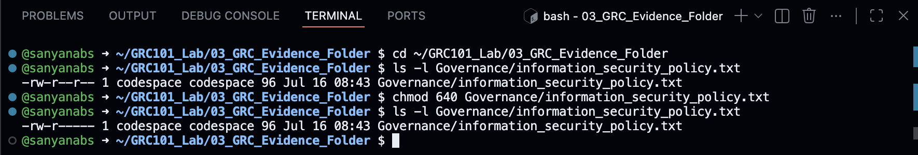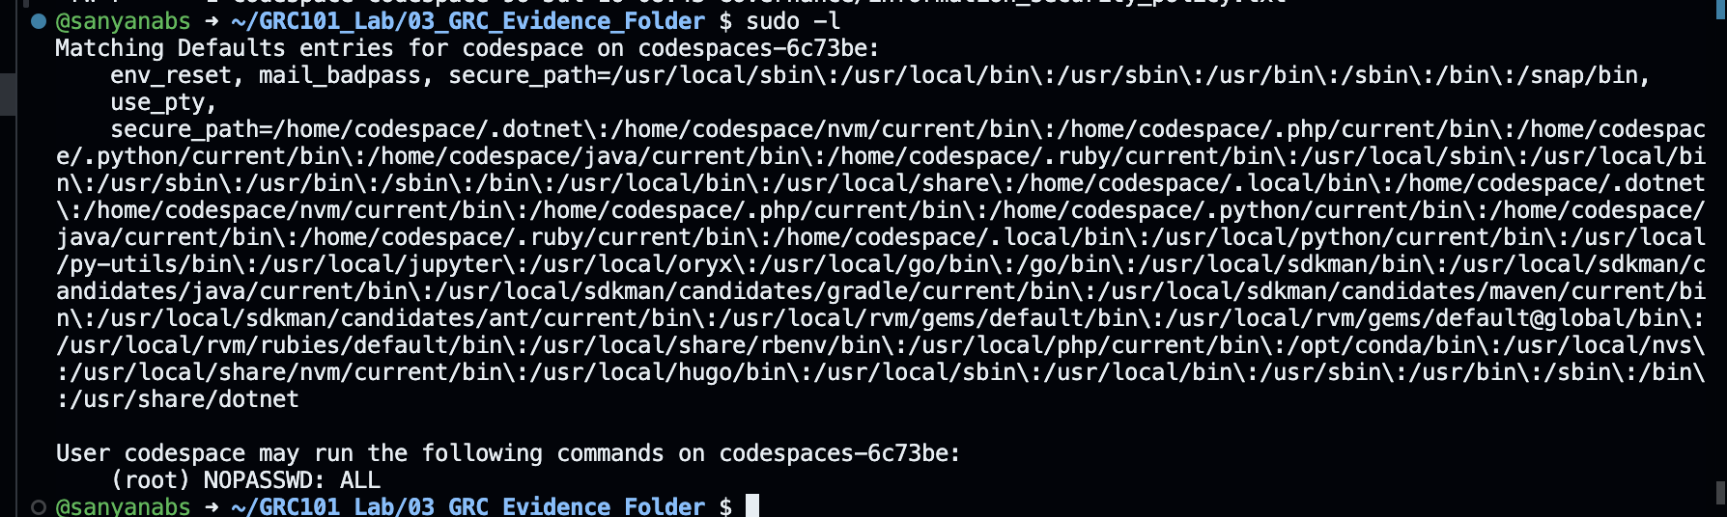

Task 10: Safely Delete Practice Files

Objective

To practice safe deletion of temporary files.

Commands Used
mkdir Temporary

touch Temporary/test_file.txt

rm Temporary/test_file.txt

rmdir Temporary

Result

Careful deletion practices help prevent accidental loss of important compliance evidence.

GRC Relevance
Controlled deletion prevents accidental loss of important evidence.

Screenshot
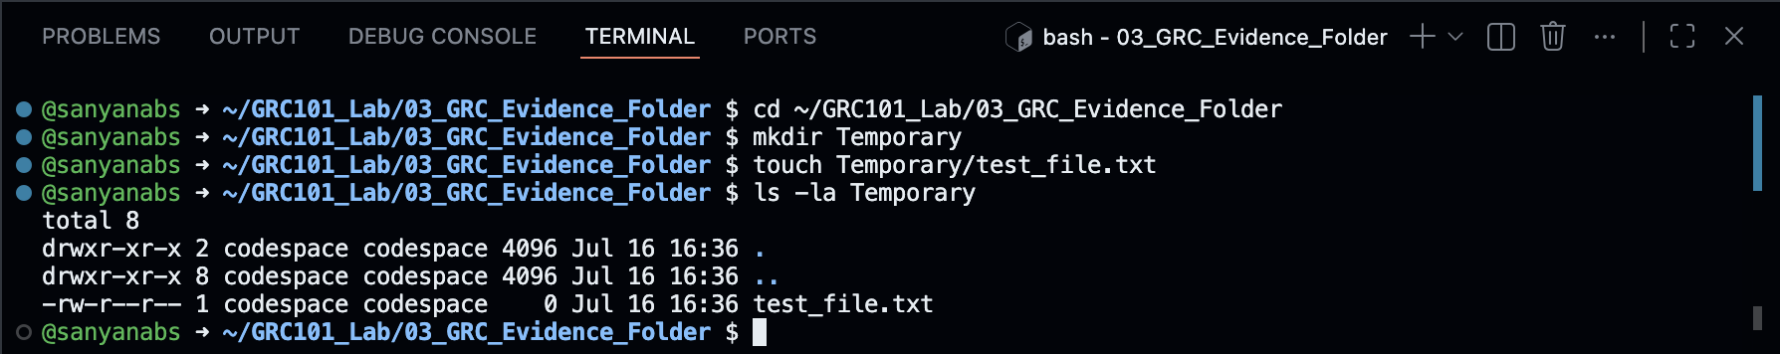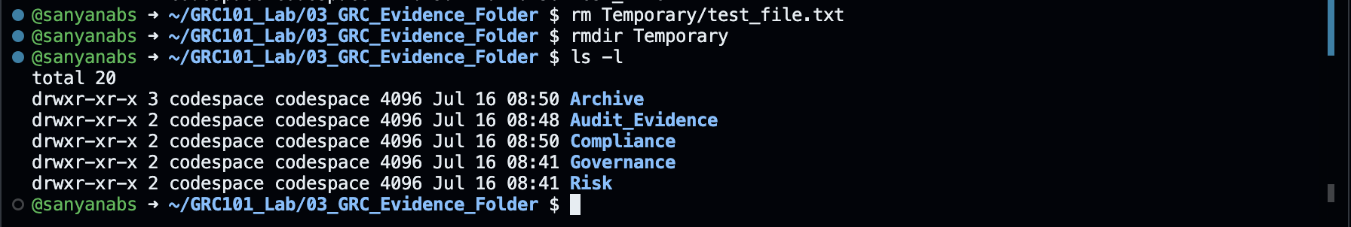

Task 11: Create README File Using Nano

Objective

To create documentation describing the purpose of the GRC evidence repository.

Commands Used
nano README.txt

cat README.txt

Result

I created a README file containing information about ownership, classification, and review frequency.

GRC Relevance

Documentation helps teams understand the purpose and management of evidence repositories.

Screenshot
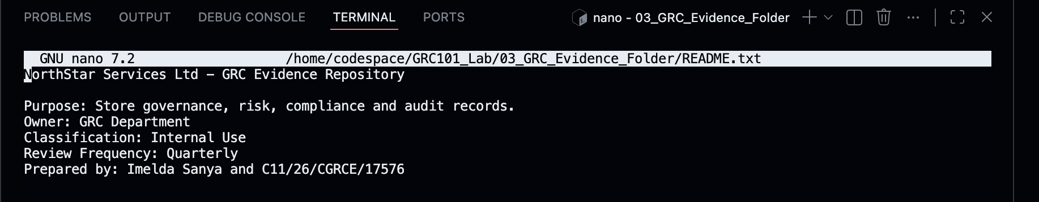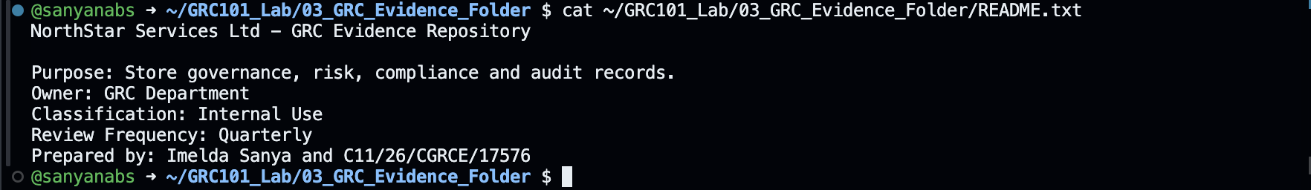

Task 12: Review Folder Structure and Compress Work

Objective

The objective was to verify the completed folder structure and create a submission archive.

Commands Used
find 03_GRC_Evidence_Folder -print

tar -czvf GRC101_C11-26-CGRCE-17576.tar.gz GRC101_Lab

ls -lh GRC101_C11-26-CGRCE-17576.tar.gz

Result
I successfully created a compressed archive containing my completed laboratory work.
I initially experienced an issue because my registration number contained /, which Linux interpreted as folders. I resolved this by replacing the slashes with hyphens.

GRC Connection
Archiving evidence helps preserve records and makes secure submission easier.

Screenshot
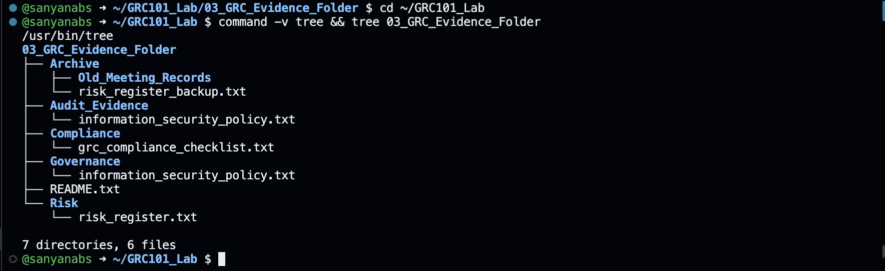

3. GRC Reflection
This practical demonstrated the importance of proper evidence management in GRC. A clear folder structure allows organisations to quickly locate policies, risk information, and audit evidence.
File permissions support confidentiality by ensuring that only authorised users can access sensitive information. Searching tools such as find and grep can help GRC professionals locate evidence efficiently.
Linux skills are valuable for cybersecurity and GRC because many security tools, servers, and compliance systems use Linux-based environments.

4. Challenges and Resolution
During this practical, I faced a few challenges while setting up my Linux environment.
Initially, I was unable to download Kali Linux, so I decided to use GitHub Codespaces as an alternative Linux environment. This allowed me to complete all required Linux activities.
I also encountered Git-related issues when I attempted commands outside the repository directory. I resolved this by checking my working directory and ensuring I was inside the correct GitHub repository.
Another challenge was creating the final archive because my registration number contained forward slashes. Linux interpreted these as folder paths, so I changed them to hyphens when creating the .tar.gz file.
These challenges improved my understanding of Linux environments and troubleshooting.

5. Conclusion
This laboratory improved my practical understanding of Linux command-line operations and how they relate to GRC engineering.
I learned how to create and manage files, organise compliance evidence, apply permissions, search information, review metadata, and securely package evidence for submission.
The skills gained from this practical provide a foundation for future work in cybersecurity, governance, risk management, and compliance.

